**SYSTEM DIGITAL**

**MODUL 3: GERBANG LOGIKA**



**By:**

**MUHAMMAD IRFAN**

**NIM: L200184165**

**INFORMATION TECHNOLOGY**

**FACULTY OF COMMUNICATION AND INFORMATICS**

**UNIVERSITY OF MUHAMMADIYAH SURAKARTA**

Name : Muhammad Irfan

Class : X

NIM : L200184165

Exercise 1

1. Make Logic Gates on picture

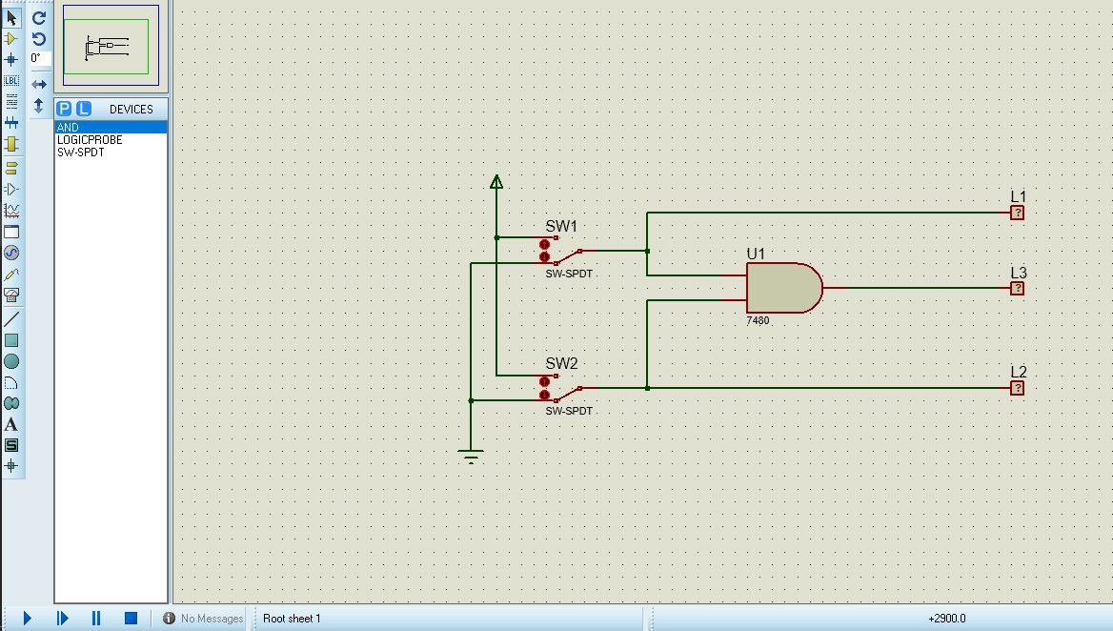

2. Truth Table.

|  |  |  |  |  |
| --- | --- | --- | --- | --- |
| S W  1 | SW  2 | L1 | L2 | L3 |
| 0 | 0 | 0 | 0 | 0 |
| 1 | 0 | 1 | 0 | 0 |
| 0 | 1 | 0 | 0 | 1 |
| 1 | 1 | 1 | 1 | 1 |

3. Diagram Time.

|  |  |  |  |  |
| --- | --- | --- | --- | --- |
| L1 |  |  |  |  |
|  |  |
|  |  |  |  |
|  |  |
| L2 |  |  |  |  |
|  |
|  |  |  |  |
|  |  |  |
| L3 |  |  |  |  |
|  |  |
|  |  |  |  |
|  |  |

Exercise 2

Exercise 2

1. Make Logic Gates on this picture

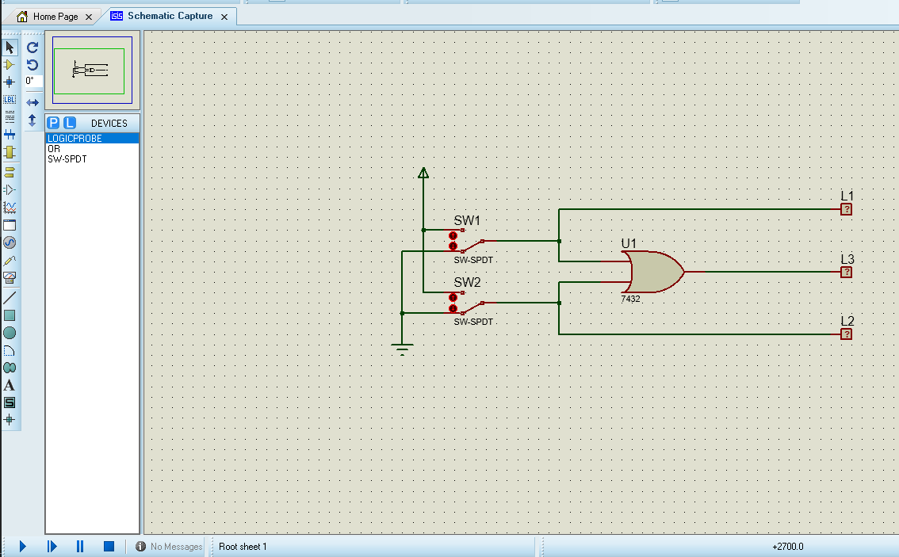

2. Truth Table.

|  |  |  |  |  |
| --- | --- | --- | --- | --- |
| S W  1 | SW  2 | L1 | L2 | L3 |
| 0 | 0 | 0 | 0 | 0 |
| 1 | 0 | 1 | 0 | 0 |
| 0 | 1 | 0 | 1 | 1 |
| 1 | 1 | 1 | 1 | 1 |

3. Diagram Time.

|  |  |  |  |  |
| --- | --- | --- | --- | --- |
| L1 |  |  |  |  |
|  |  |
|  |  |  |  |
|  |  |
| L2 |  |  |  |  |
|  |  |
|  |  |  |  |
|  |  |
| L3 |  |  |  |  |
|  |  |  |  |
|  |  |

Exercise 3

1. Make Logic Gates on this Picture.

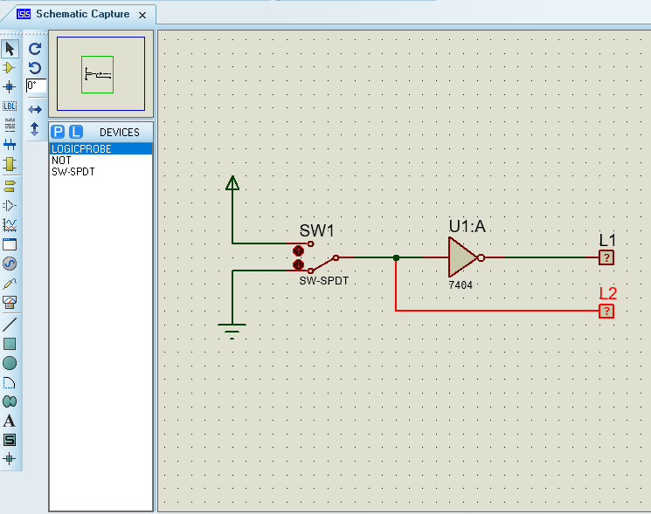

2. Truth Table.

|  |  |  |
| --- | --- | --- |
| S W  1 | L2 | L1 |
| 0 | 0 | 1 |
| 1 | 1 | 0 |

3. Diagram Time.

|  |  |  |
| --- | --- | --- |
| L1 |  |  |
|  |
|  |  |
|  |
| L2 |  |  |
|  |
|  |  |
|  |

Exercise 4

1. Make Logic Gates on this Picture.

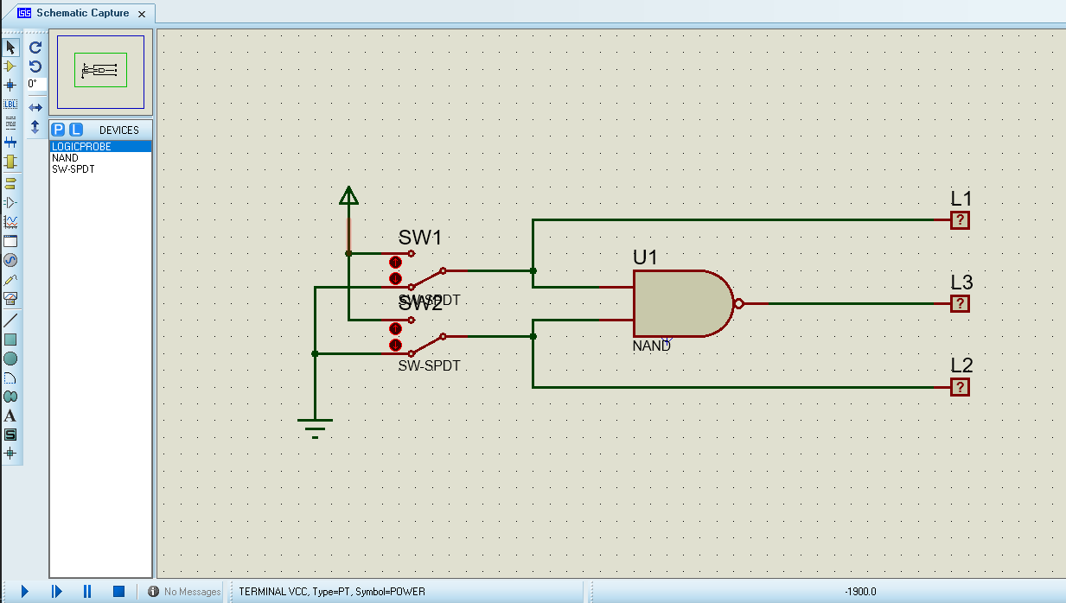

2. Truth Table.

|  |  |  |  |  |
| --- | --- | --- | --- | --- |
| S W  1 | SW  2 | L1 | L2 | L3 |
| 0 | 0 | 0 | 0 | 1 |
| 1 | 0 | 1 | 0 | 1 |
| 0 | 1 | 0 | 1 | 1 |
| 1 | 1 | 1 | 1 | 1 |

3. Diagram Time.

|  |  |  |  |  |
| --- | --- | --- | --- | --- |
| L1 |  |  |  |  |
|  |  |
|  |  |  |  |
|  |  |
| L2 |  |  |  |  |
|  |  |
|  |  |  |  |
|  |  |
| L3 |  |  |  |  |
|  |  |  |  |
|  |  |  |  |

Exercise 5

1. Make Logic Gates on this Picture.

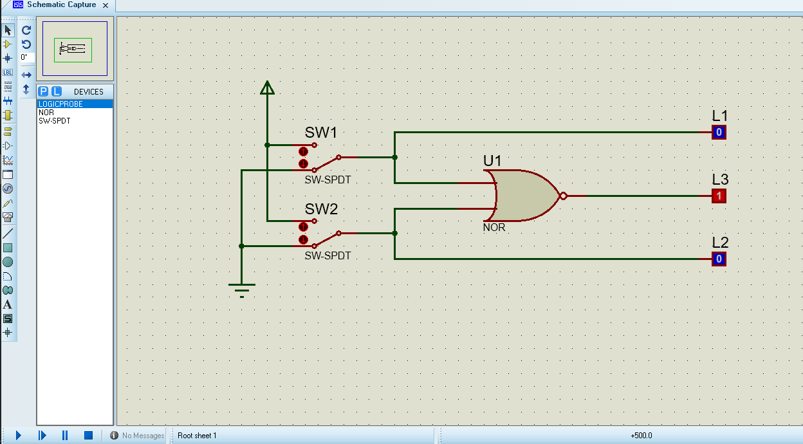

2. Truth Table.

|  |  |  |  |  |
| --- | --- | --- | --- | --- |
| S W  1 | SW  2 | L1 | L2 | L3 |
| 0 | 0 | 0 | 0 | 1 |
| 1 | 0 | 1 | 0 | 0 |
| 0 | 1 | 0 | 1 | 1 |
| 1 | 1 | 1 | 1 | 0 |

3. Diagram Time.

|  |  |  |  |  |
| --- | --- | --- | --- | --- |
| L1 |  |  |  |  |
|  |  |
|  |  |  |  |
|  |  |
| L2 |  |  |  |  |
|  |  |
|  |  |  |  |
|  |  |
| L3 |  |  |  |  |
|  |  |
|  |  |  |  |
|  |  |

Exercise 6

1. Make Logic Gates on this Picture.

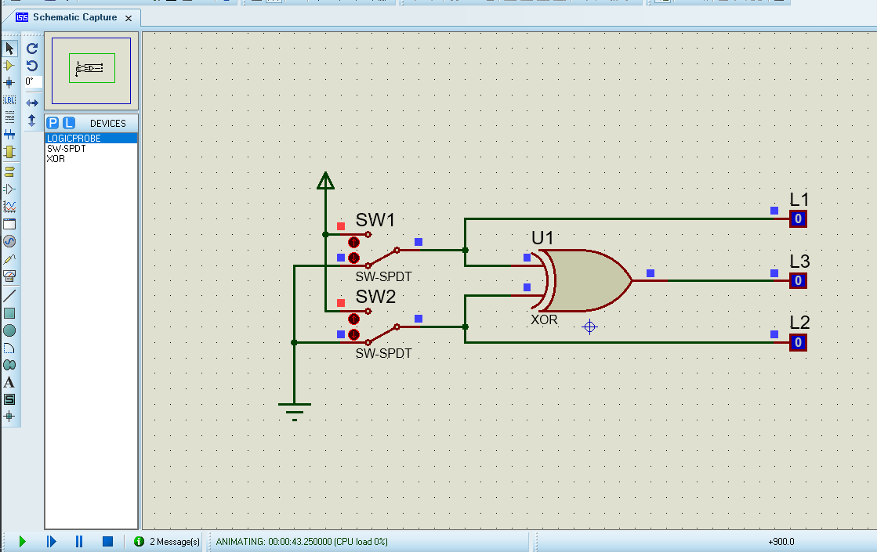

2. Truth Table.

|  |  |  |  |  |
| --- | --- | --- | --- | --- |
| S W  1 | SW  2 | L1 | L2 | L3 |
| 0 | 0 | 0 | 0 | 0 |
| 1 | 0 | 1 | 0 | 1 |
| 0 | 1 | 0 | 1 | 1 |
| 1 | 1 | 1 | 1 | 0 |

3. Diagram Time.

|  |  |  |  |  |
| --- | --- | --- | --- | --- |
| L1 |  |  |  |  |
|  |  |
|  |  |  |  |
|  |  |
| L2 |  |  |  |  |
|  |  |
|  |  |  |  |
|  |  |
| L3 |  |  |  |  |
|  |  |
|  |  |  |  |
|  |  |

Exercise 7

1. Make Logic Gates on this Picture.

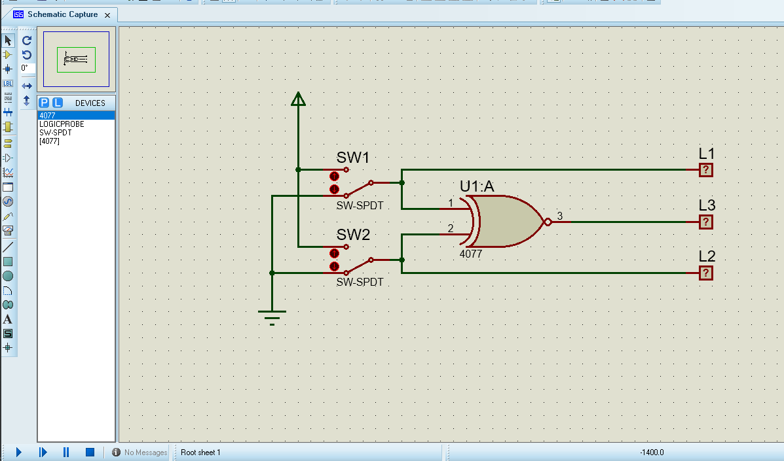

2. Truth Table.

|  |  |  |  |  |
| --- | --- | --- | --- | --- |
| S W  1 | SW  2 | L1 | L2 | L3 |
| 0 | 0 | 0 | 0 | 1 |
| 1 | 0 | 1 | 0 | 0 |
| 0 | 1 | 0 | 1 | 0 |
| 1 | 1 | 1 | 1 | 1 |

3. Diagram Time.

|  |  |  |  |  |
| --- | --- | --- | --- | --- |
| L1 |  |  |  |  |
|  |  |
|  |  |  |  |
|  |  |
| L2 |  |  |  |  |
|  |  |
|  |  |  |  |
|  |  |
| L3 |  |  |  |  |
|  |  |
|  |
|  |  |  |  |
|  |